1. What 2 Java reference types can be used in order to solve Observer's memory leak problem?

* **Weak and Phantom**
* Soft and Weak
* Soft and Phantom
* Final and Phantom

1. The following high-level GoF description defines the ____________ design pattern

... is a software design pattern in which an object, called the subject, maintains a list of its dependents and notifies them automatically of any state changes, usually by calling one of their methods.

* Command
* Visitor
* **Observer**
* Strategy

1. What Design Pattern is used in the following UML diagram?

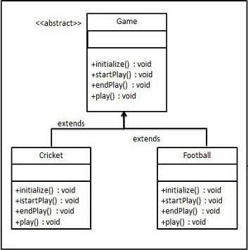

* Abstract Factory
* **Template Method**
* Composite
* Strategy

1. USED Which of the following is a concrete observer?

* IPerson
* **Employee**
* Announcement
* ISubject

1. Which usage is **NOT** recommended for the Command pattern

* History of the request is being tracked
* A callback functionality has to be provided
* The invoker should be de-coupled from the object handling the invocation
* **The receiver objects have to be linked together**

1. DogSimulatorApp is probably using the ____________ design pattern

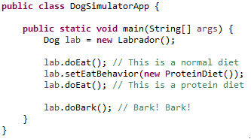

* **Strategy**
* Observer
* Composite
* Visitor